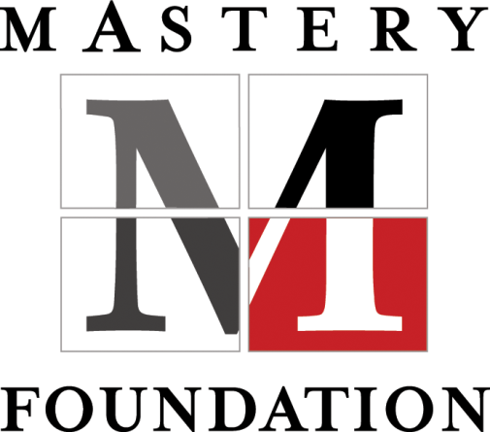
Making a Difference:
A Course for
Those Who
Minister

An interfaith, three-day workshop
for lay and ordained persons in ministry

Tuition: $300
$150 special rate for
CTU students
CATHOLIC THEOLOGICAL UNION
September 12-14, 2014
Schedule:
9am to 6pm each day

Location:
Catholic Theological Union
5416 South Cornell Avenue
Chicago, IL 60615

Arrangements can be
made for overnight
accommodations for
an additional fee

Contacts and Registration:
John or Carole are available to discuss the workshop with you at your request.
Please email then with your information and they
will contact you.
Fr. John Eybel
773-306-5036
jeybel@hotmail.com
or
Carole Schurch
415-296-7865
schurch.schurch@gmail.com
To register, contact
one of them or go to
http://www.masteryfoundation.org/interfaith/schedule/index.php

Ministry today requires the ability to inspire others to participate and to be involved, and the strength of mind to respond in new and difficult situations in a changing world. These challenges require that a minister listen and lead in new and creative ways.

Making a Difference: A Course for Those Who Minister provides you with new tools that empower you to deal effectively with those issues that are most basic, most urgent — the daily business of ministry, the spirit and heart of fully living out your calling, making thoughtful choices, relating powerfully to others, and having your life and ministry make the difference you want them to make.

This unique program is an opportunity to
- Meet, share, and learn from other participants dealing with the challenges of ministry
- Step back to reflect on and explore the background or underlying ideas that so strongly influence and shape our everyday actions
- Develop your ability to listen in a way that opens up new levels of insight, compassion, and possibility in your work with others
- Create an empowering context for your ministry, a context that you can continually renew and one that renews you
- Enrich and deepen your prayer life

The course includes lecture and dialogue, small group work, and daily periods of Centering Prayer. It is led by a team of volunteer lay and ordained leaders with years of experience in the course methodology.

The course does not give easy answers, tips or rules. Instead it offers a technology for getting your hands on your own power and effectiveness. It is about providing us with a path on which we shape our future rather than just being shaped by it.

You will leave the program with new confidence in the difference you can make and new tools that will empower your ministry now and grow in value and usefulness over time.

