Mastery Foundation

Making A Difference: A Course for Those Who Minister
Course Registration Form

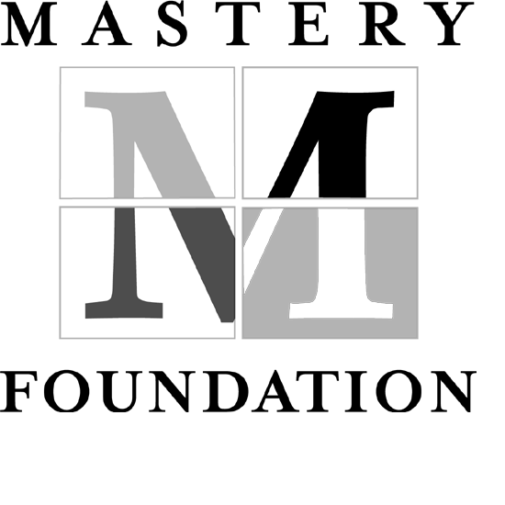

Thank you for your interest in the Mastery Foundation Making A Difference Workshop.

To register, please complete this form with the requested information, save it on your computer in a location that you will remember, and send it as an e-mail attachment to: information@masteryfoundation.org

Location and date of course that you are registering for:
Last Name:
First Name:
Name you like to be called:
Your Title:
Address:
City:
State/Zip:
Home Phone:
Work Phone:
E-mail address:
A non-refundable deposit of $50 will reserve your place in the workshop.
Payment is due in full three weeks before the program begins. If you would
like to pay by credit card, we ask you to make one payment for the full
amount (tuition plus room and board). Please indicate the method of payment you will be using:
Check Visa Mastercard
Religion:
Area(s) of ministry/service:
How did you hear about the workshop?:

As soon as we receive your registration information, someone from the Mastery Foundation will call you to complete your course registration. Thank you.

